Name: Tran Khanh Tai
ID: ITITIU21300
Lab 3
Task 2.1
Demo:
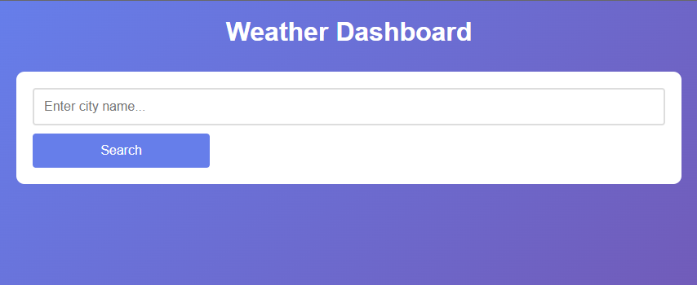
This appear when we start

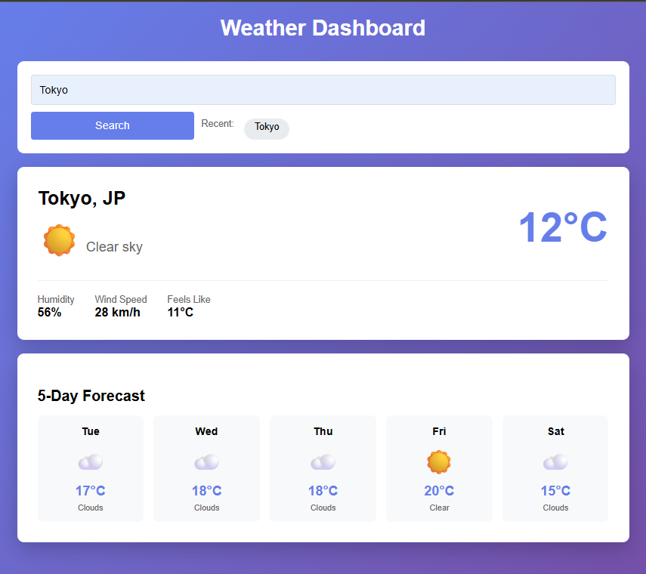
When we search for a city and this name will store in recent searched
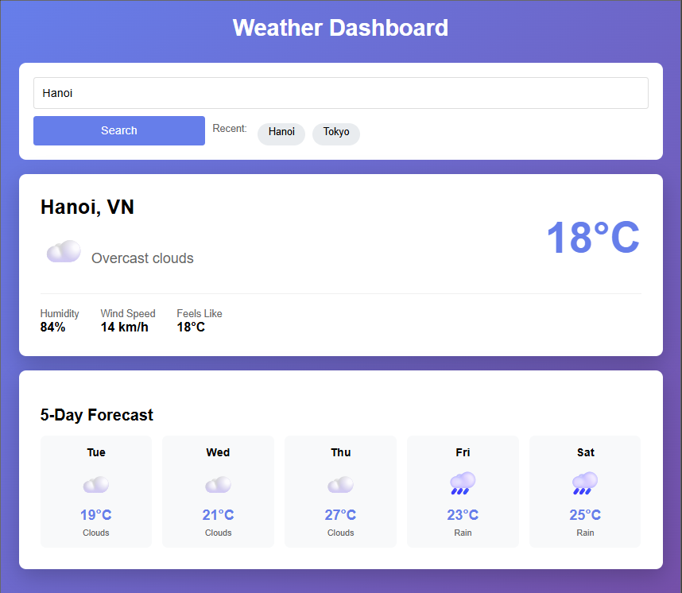
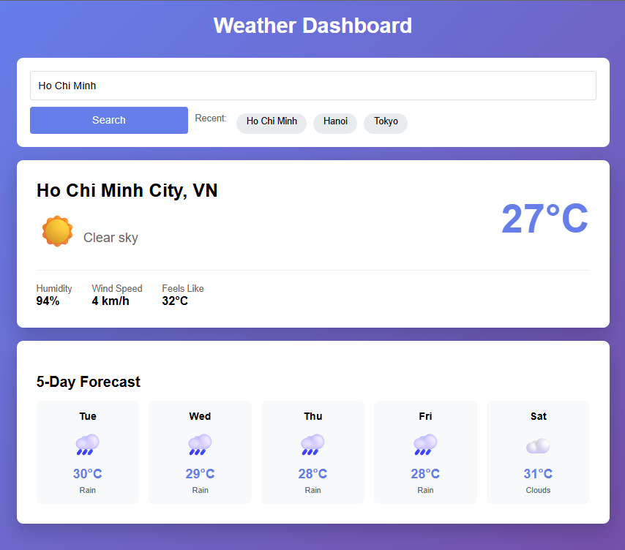

Task 2.2:
First look
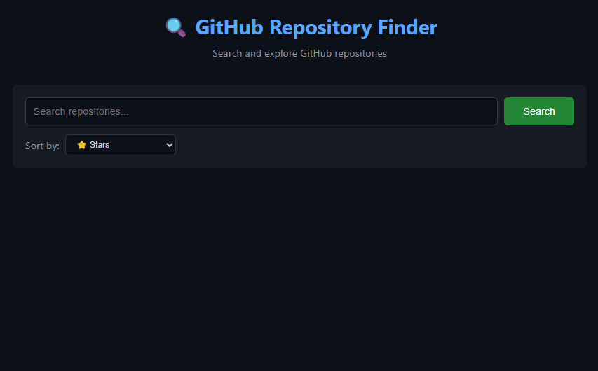

Here is when you search for a repo
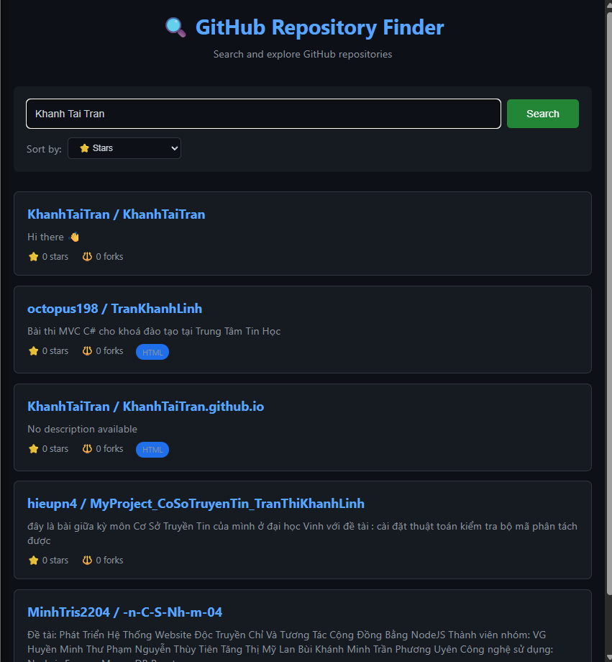

And for an resutl with more than 10 repo card, it will appear an load more button
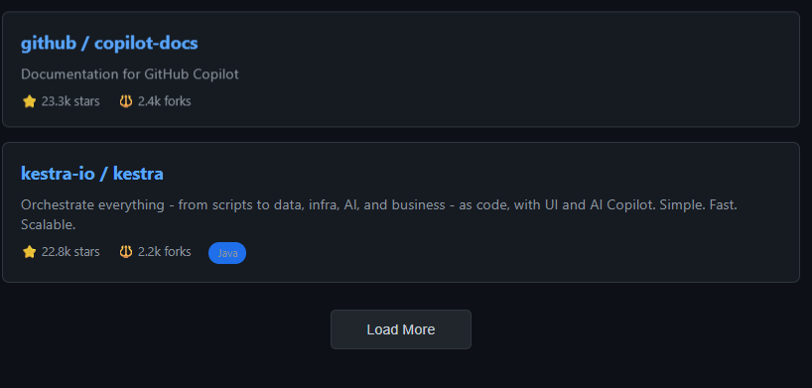

You also can sort the result by Stars, Forks and Recent Update
